**CS408 Incremental Testing, Regression Testing**

**Team 2 InfoCrawler**

**Hanxun Huang, Sun Kai, Yijie Wu, Longding Zhang, Di Yao**

1. **Classification of Components**

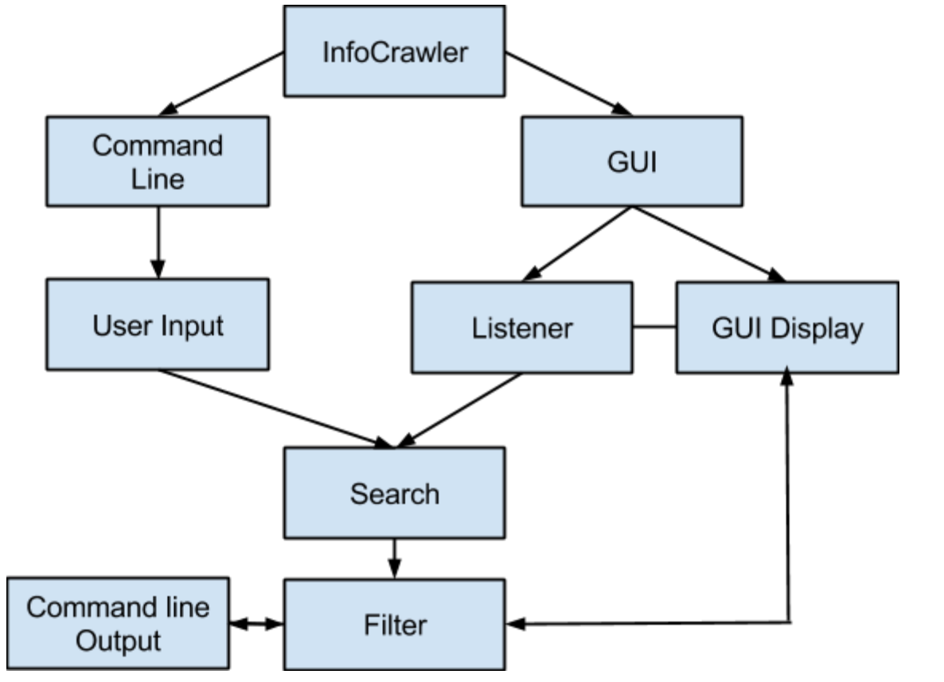

There are 8 components in the program. The input and output of each components as follows

**(1)Command Line**

Input: Argv input (If the user decided to use)

Output: Call the User Input Component

**(2)User Input**

Input: Called by Command Line

Output: SearchSetting Class

**(3)GUI**

Input: None (User enter command to open GUI)

Output: Calls GUI display and Listener

**(4)GUI Display**

Input: Called by GUI component, SearchResult Class from filter

Output: Value of each input field, call the Listener components

**(5)Listener**

Input: Called by GUI component, Value of each GUI input field.

Output: SearchSetting Class

**(6)Search**

Input: SearchSetting Class

Output: SearchResult Class

**(7)Filter**

Input: User selection and input, SearchResult Class

Output: SearchResult Class (Modified)

**(8)Command Line Output**

Input: SearchResult Class

Output: Command Line printout or save to a file.

We will use Bottom-up incrementing testing. Because of the main functions of the system are the search and filter component that are located in bottom of the system (Test critical module as early and often as possible). The driver is easy to produce than the stub. For example, the driver for search component is simple a SearchSetting Class with the set field value.

|  |  |  |  |
| --- | --- | --- | --- |
| Module | Command Line Output | | |
| Incremental Testing | | | |
| Defect# | Description | Severity | How To Correct |
| 1 | IndexOutOfBound Exception when print out the result from regular expression search return. | 1 | Get the return string length before print out. |
| Regression Testing | | | |
| Defect# | Description | Severity | How To Correct |
| 1 | WordByWord search method will also cause the IndexOutOfBound Exception if there are a lot of matched string | 1 | Add Search Result class with a filed record the length of the string[] or count number of the matched string. |

|  |  |  |  |
| --- | --- | --- | --- |
| Module | Search | | |
| Incremental Testing | | | |
| Defect# | Description | Severity | How To Correct |
| 1 | System no response when the keyword do not exist | 2 | If the no matched keyword is found, printout message and return. |
| 2 | Input non-plain text file will cause java.lang.NullPointerException (Such as .pdf) | 1 | Build a method to check input file before search. |
| 3 | WordByWord search method will cause StringIndexOutOfBoundsException when the URL content is very long | 1 | Create string dynamically, get the length of the URL content string and create search string. |
| 4 | Repeat Mode URL increment variable replace method will causing exception if “XXX” do not exist in the URL String | 1 | Check “XXX” exist in the URL before call the replace method |
| 5 | HTML element search no response | 2 | Convert HTML element into two keyword and call search(). |
| 6 | If the keyword is null should return content of the URL | 2 | Check if the keyword is empty, set the result string to content of the URL instead of call search() |
| 7 | Should able to use filter function during periodic mode execution | 3 | Add option to use filter in periodic mode. |
| Regression Testing | | | |
| Defect# | Description | Severity | How To Correct |
| 1 | WordByWord search method will still cause StringIndexOutOfBoundsException if the keyword is very long | 1 | Create string dynamically, get the length of the input string and create search string. |
| 2 | If the second keyword is null should return all the URL content after the first keyword is found | 3 | Add a method to handle null input condition in two different search function and modify the search result class |

|  |  |  |  |
| --- | --- | --- | --- |
| Module | User Input | | |
| Incremental Testing | | | |
| Defect# | Description | Severity | How To Correct |
| 1 | In periodic mode the input can be negative and cause the exception | 1 | Check the negative input and ask the user to input again if it is the negative |
| 2 | In Repeat Mode, get_url_content only checked once using increment_range_from will causing exception if the URL page did not exist within the increment range. | 2 | Also check the increment_range_to |
| 3 | Arrow Key does not work. No input history. | 3 | Build a arrow key listener. Add input history string[] |
| Defect# | Description | Severity | How To Correct |
| 1 | Input number larger than largest Integer will ask for another integer, should also alert user the input is larger than the max allowed integer in time interval part. | 3 | Add printout message if the input is out of range |
| 2 | Input double or float number will ask for integer in time interval part. | 3 | Convert the double into integer or modify the time interval (timer) as double type . |
| 3 | If there is non-exist page during the increment URL range will also cause the exception | 2 | Printout there is non-exist page within the increment URL range and handle the exception |

|  |  |  |  |
| --- | --- | --- | --- |
| Module | Command Line | | |
| Incremental Testing | | | |
| Defect# | Description | Severity | How To Correct |
| 1 | Too much input not very easy to use | 3 | Add argv input method. |
| Regression Testing | | | |
| Defect# | Description | Severity | How To Correct |
|  | None |  |  |

|  |  |  |  |  |  |
| --- | --- | --- | --- | --- | --- |
| Module | GUI Display | | | | |
| Incremental Testing | | | | | |
| Defect# | Description | | | Severity | How To Correct |
| 1 | Users cannot create tabs. | | | 3 | Add four tabs for users to do multiple tasks. |
| Regression Testing | | | | | |
| Defect# | Description | Severity | How To Correct | | |
|  | None |  |  | | |

Note:

GUI Listener and Filter did not implemented yet.